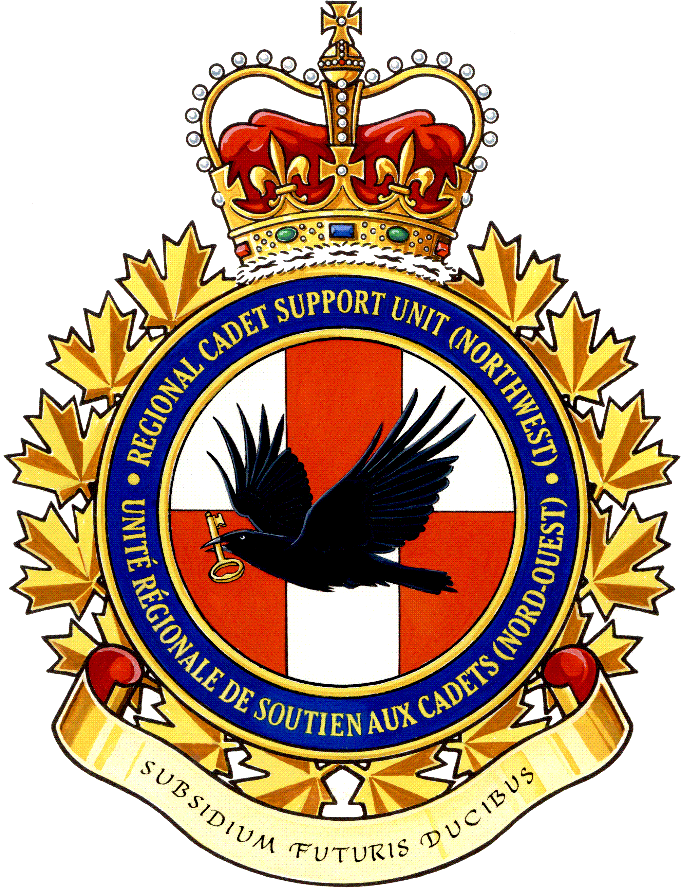
SUMMER TRAINING CHOICES

Level One (Two Weeks)

• Γενεραλ Training Course (GTC)

Minimum Level Two (Three Weeks)

• Βασιχ Drill and Ceremonial Course (BDCC)
• Βασιχ Survival Course (BSC)
• Βασιχ Fitness and Sports Course (BFSC)
• Βασιχ Aviation Course (BAC)
• Βασιχ Aviation Technology and Aerospace
Course (BATAC)
• Μιλιταρψ Band - Basic Musician Course (MB-BMC)
• Πιπε Band - Basic Musician Course (PB-BMC)

Minimum Level Three (Three and Six Weeks)

• Αδϖανχεδ Aviation Course (AAC) (Three Week Course)
• Δριλλ and Ceremonial Instructor Course (DCIC)
• Συρϖιϖαλ Instructor Course (SIC)
• Φιτνεσσ and Sports Instructor Course (FSIC)
• Αιρ Rifle Marksmanship Instructor Course (ARMIC)
• Μιλιταρψ Band - Intermediate Musician Course (MB-IMC)
• Πιπε Band - Intermediate Musician Course (PB-IMC)

Minimum Level Four (Six Weeks)

• Μιλιταρψ Band – Advanced Musician Course (MB-AMC)
• Πιπε Band – Advanced Musician Course (PB-AMC)

Staff Cadet (Seven Weeks)

• Ποσιτιονσ αϖαιλαβλε ατ ϖαριουσ Χαδετ Τραινινγ Χεντρεσ

National Courses (Three to Seven Weeks depending on the course / exchange)

• Αδϖανχεδ Aerospace Course (AASC)
• Αδϖανχεδ Aviation Technology Course – Airport Operations (AATC-AO)
• Αδϖανχεδ Aviation Technology Course – Aircraft Maintenance (AATC-AM)
• Γλιδερ Pilot Scholarship (GPS)
• Ποωερ Pilot Scholarship (PPS)
• Ιντερνατιοναλ Air Cadet Exchange (IACE
Level: _______________

Name: __________________________________________________
Choices (may choose as many as you are eligible for): ________________________________________________________
________________________________________________________
________________________________________________________
________________________________________________________
________________________________________________________
Is the Cadet available for the entire duration of the requested courses, positions or activities? Yes No
Would the cadet like to be considered for other courses, positions, or activities? Yes No
Is the cadet a Canadian Citizen? Yes No
Any restrictions on dates or special details that we should be aware of: ________________________________________________________
________________________________________________________
________________________________________________________
Level Officer Recommendation:
________________________________________________________
________________________________________________________
________________________________________________________
If applicable:
GPS/PPS: Weight (Kgs) ____ Height (cms) ____

Aviation Technology Courses (AM/AO):

Height _____ Waist ______ Boot Size _______
(cms) (cms) (inches)

Cadet Signature: __________________________

Parent Signature: ________________ _________

