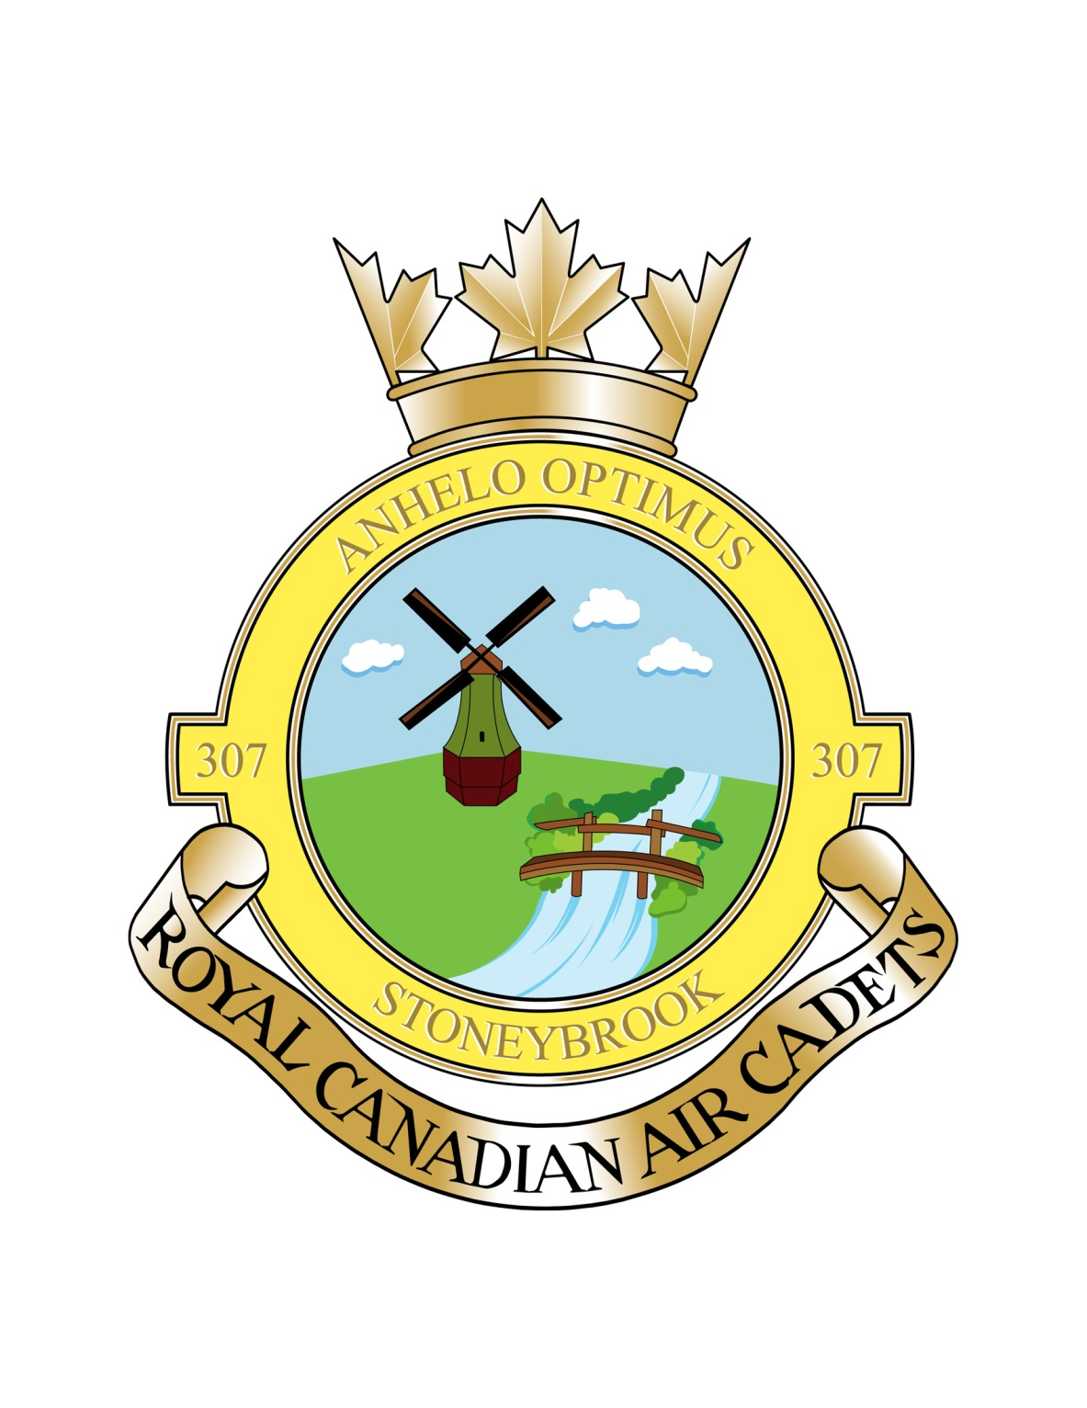
307 STONEYBROOK
ROYAL CANADIAN AIR CADET SQUADRON
WELCOME PACKAGE
September 2017
1 Document Overview......................................................................................... 2
1.1 Purpose ...................................................................................................3
1.2 Audience..................................................................................................3
1.3 Other Related Information ......................................................................3
2 Welcome ............................................................................................................3
3 Time Commitment ............................................................................................4
3.1 Regular Parades .....................................................................................4
3.2 Sports ......................................................................................................4
3.3 Ground School ........................................................................................4
4 Local Sponsoring Committee (The Parents)..................................................5
5 Main Events/Programs – Cadet Based............................................................6
5.1 Annual Ceremonial Review (ACR) and Awards Banquet.......................6
5.2 Scholarship Boards .................................................................................7
5.3 Gliding......................................................................................................7
5.4 Familiarization Flying (FAM Flights) .......................................................7
5.5 Summer Training.....................................................................................7
5.6 Citizenship Tours..................................................................................7
5.7 Inter-Squadron Activities.....................................................................7
6 Main Events/Programs – Parent Sponsored Based......................................8
6.1 Effective Speaking..................................................................................8
6.2 Mock Selections Boards .........................................................................8
6.3 Duke of Edinburgh Youth Challenge Program .......................................8
6.4 Squadron Photos ....................................................................................8
7 Uniform ..............................................................................................................9
8 Fundraising .......................................................................................................9
9 Contacts ............................................................................................................9
9.1 Chain of Command................................................................................10
9.2 Local Sponsoring Committee Executive – Contact Info........................10
9.3 Officers and Staff – Contact Info............................................................10
10 Glossary...........................................................................................................11

1 DOCUMENT OVERVIEW
1.1 Purpose
This document presents cadets and parents/guardians with an overview and general information pertaining to 307 Stoneybrook Squadron and to Air Cadets, in general. It is intended as a welcome package for new families. If you do not find the answers to your questions in this package, please do not hesitate to contact the Commanding Officer or the Local Sponsoring Committee Chairperson. Contact information can be found in the appropriate section of this package.
1.2 Audience
This document is intended for all new families that have recently joined the 307 Stoneybrook Air Cadet Squadron or as a reference for experienced cadet families.
1.3 Other Related Information
- National website for Royal Canadian Air Cadets – www.cadets.ca
- Air Cadet League of Canada website – www.aircadetleague.com

2 WELCOME
Welcome to the Air Cadet Program! The aim of the Royal Canadian Air Cadets is to develop in youth the attributes of good citizenship and leadership, to promote physical fitness and to stimulate an interest in the air element of the Canadian Forces. For the youth, this many mean they wish to learn how to fly, they desire a sense of achievement, or they want to excel at leadership. Air Cadets is one of Canada’s most outstanding youth programs.
For parents/guardians, be rest assured that the Cadet Program does not imply that your child/ward is automatically destined for a military career. Cadets are not conditioned by this program to join the military. Youth in this program will develop skills and behaviors that will prepare them for any career. Some may choose the Military career path, but whatever path a cadet chooses, he or she will be better equipped after learning the discipline, fellowship and skills that are part of this program.
The age range for cadets is 12-18 years old and is open to both males and females. Keep in mind that even though there is no charge to enrol in Air Cadets, parents and their cadets are strongly encouraged to participate in fundraising events throughout the year such as Sobeys, Spud and Steak dinners, etc. This gives the Squadron a sense of community, funds the optional training and activity programs, and pays the rent and phone bills. The price of being a cadet is commitment. Remember that behind every successful cadet is an active and dedicated parent.

3 TIME COMMITMENT
Cadets are required to attend Thursday evening parades from 6:15 – 9:00 pm. Some mandatory activities are held on weekends and other evenings during the week. These are the ones your cadet would sign up for such as gliding, familiarization flights, weekend survival exercises, ground school, etc. There will also be community service duties and fundraising activities that will happen on weekends. There are also some mandatory parades that take place during the year such as Remembrance Day and the Annual Ceremonial Review (usually held the first week in June). Those cadets interested in Summer Training and or Scholarships must maintain a 75% attendance throughout the training year to be considered.
Regarding the mandatory Annual Ceremonial Review (ACR), scholarship and summer training quotas are set by the attendance at the ACR; therefore, if a cadet fails to attend this parade, he/she will be removed from the eligible candidate list for summer training the next training year – unless, of course, a valid written excuse is presented to the Commanding Officer from the cadet parent.
The entire Cadet Program is run by the Department of National Defence (DND) and is staffed by highly motivated trained officers. The following program information in this welcome document is provided simply as a parent/guardian introduction to the current activities in place at 307 Stoneybrook Squadron and is not intended to set policy or procedures as dictated by the DND.
3.1 Regular Parades
Thursday Evenings 6:15 to 9:00 pm September to June
Friedensfeld Community Centre Cadet Office phone TBA

Cadets are expected to arrive by 6:15 pm and follow the direction of the level Training Officers and senior cadets. Cadets are expected to bring a notebook and pens to be able to take down notes and announcements during cadets. Training Officers will focus on content from the training manuals and will test for comprehension. One training year will generally cover one level of the Cadet Program from Levels 1 through 5. Cadets who join at age 14 or older have the opportunity to be accelerated. These older cadets may complete Level 1 and 2 in one year.
Attendance, deportment, and participation at regular parade nights and mandatory activities are noted and used to determine qualification for summer scholarships and end of the year awards.
At the end of each evening (approximately 8:45 pm), the cadets meet in the parade square (main area) for the final evening parade. The cadets are dismissed by 9:00 pm SHARP although cadets do take turns doing orderly or “clean up duty”. Please be courteous to the officers and staff and be on time for pick up. Signup sheets for flying and other activities are posted and parents are advised to take note of all activities their cadet has signed up for.
The first parade of each month is called the Commanding Officer’s parade and during this parade, all cadets are thoroughly inspected. Cadets are strongly encouraged to ensure their hair and uniform are all in good order. Cadets will require to purchase a small tin of KIWI black boot polish and a KIWI polishing cloth. As well, each cadet is required to bring $6.00 to purchase two name tags for their uniform.
3.2 Sports
Physical fitness is a part of the cadet program. Our office staff encourage fun and fitness rather than competitive achievement. Annually, cadets participate in Canada Fitness Testing and may be eligible to achieve a badge for their uniforms. Cadets must participate in 1 of the 2 Fitness Testing activities to be eligible for promotion.
3.3 Ground School
This optional activity runs one evening each week at the Friedensfeld club house or Steinbach library starting mid-September. This is available only to Level 3 cadets or higher. This course is mandatory for cadets who are competing for Gliding or Flying scholarships.
3.4 Attendance
All parents/guardians of cadets (who do not drive themselves to parade nights) must sign out their child at the end of every night. This ensures the safety of the cadet as well as parents are very welcome and encouraged to come into the main hall to watch the final parade. Many announcements are made at this time and it is a good opportunity to find out what is happening with your cadet, including upcoming sponsoring committee information.
3.4a
Excused absences will be allowed for school (such as studying for and exam or test etc), family emergency or sickness. We expect the same level of respect regarding this as you would give your child’s school. Those cadets interested in Summer Training and or Scholarships must maintain a 75% attendance throughout the training year to be considered.

4 LOCAL SPONSORING COMMITTEE (THE PARENTS)
This group is often referred to as the Parent Committee and is made of all the cadet parents or guardians enrolled in the Squadron. If you have a cadet in the squadron, you are automatically a member.
This non-profit registered charity was established to run the business of 307 Stoneybrook Squadron. This Committee raises funds to operate the Squadron (rent, phone, etc) to run the squadron over and above the DND-funded cadet-based activities.
In addition, the Sponsoring Committee support the Squadron (our cadets) by:
- Cooking at weekend training exercises
- Running the canteen during parade nights
- Chaperoning during activities such as gliding, survival exercises, etc.
- Making new cadets and parents feel welcome
- Providing volunteers for use in cadet-based activities as directed by the CO
- Maintaining the squadron headquarters
- Sponsoring the Effective Speaking competition
- Cadet and Officer recruitment drives
Local Sponsoring Committee members are open to all cadet parents and are held bi-monthly (location to be announced). The meetings generally last about 2 hours and cover the general operation of the Squadron. All parents/guardians are strongly encouraged to attend these meetings as a wealth of information is shared about cadet functions, the progress towards special activities and initiative, date or schedule changes, and opportunities to volunteer. Please send at least one parent/guardian to take notes.
The Local Sponsoring Committee, as a registered charity, must annually elect an executive board. These individuals work on behalf of all members of the committee in roles defined in part by the Local Sponsoring Committee by-laws. This committee works in partnership with the military side of the squadron represented by the Commanding Officer and staff. The Executive meets monthly and makes progress reports to the Local Sponsoring Committee meetings.
The Local Sponsoring Committee is the squadron’s representation to the Air Cadet League of Canada. The Local Sponsoring Committee reports to and takes direction from the Provincial and National committees of the Air Cadet League of Canada. The Air Cadet League is a non-profit organization that governs the Local Sponsoring Committee at the squadron level. They provide insurance, oversight and encourage/fund collaborative efforts amongst and between all the squadrons.

5 MAIN EVENTS/PROGRAMS – CADET BASED
5.1 Annual Ceremonial Review (ACR)
This parade symbolizes the culmination of your cadet’s efforts during the training year and marks the beginning of summer training session. Attendance at this parade is a critical element in the cadet’s successful completion of their training level.
This parade is not only important for recognizing the achievements of the cadets and the Squadron during the past training year, but it is the single most critical day of the entire training year for your cadet to be in uniform and to be present for the parade. The more cadets that are on parade, the greater the number of scholarships the Squadron will be eligible to achieve, the more cadets that will be selected to attend summer training and the greater the training budget for future years.
This event is normally held the beginning of June. Parents, guardians, and guests are invited. A banquet is held immediately after the Ceremonial Parade.
Cadets not in attendance shall be required to have their parents/guardians submit a letter of explanation to the Commanding Officer explaining the reason for the absence. Cadets without a valid excuse shall risk having their name placed below cadets who attended and participated in the parade on the following year’s summer training selection nominations.
5.2 Scholarship Boards
To be selected for senior summer training courses, such as power and glider pilot training, the squadron sends its best candidates to Provincial Selection Board interviews in Winnipeg. Our cadets compete with other squadrons for a limited number of spots on these courses. Some of the most prestigious courses, notably pilot training courses, have quotas applied so that smaller squadrons have an equal opportunity compared to the urban squadrons with more resources. The quota is based on the number of cadets enrolled in a particular squadron, as measured at the Annual Ceremonial Review the previous year.
The scholarship courses that are awarded based on Selection Boards are:
- International Exchange
- Power Pilot
- Glider Pilot
5.3 Gliding
Gliding is done in Gimli in spring and fall each year. Cadets are transported via bus to Gimli and spend the day gliding and learning about aviation.

5.4 Familiarization Flying (FAM Flying)
The greatest reason for youth to join Air Cadets is often to experience the thrill of flight. DND does not pay for flying; therefore, the Local Sponsoring Committee must come up with the extra funds to take our cadets flying
5.5 Summer Training
There are a number of summer training opportunities for cadets such as General Training, Cadet Musician, Leadership and Ceremonial Review, Introduction to Aviation, Physical Fitness, and Aircrew Survival. A Level 1 Cadet can only apply to attend the following summer training:
- General Training (two week course in Cold Lake, Alberta)
Not all cadets who apply for summer training will receive the privilege of attending. Each Squadron has a summer training quota allotted to them by DND, and there will be times when the number of applications will outnumber the Squadron’s allotted summer training slots. There is more about summer training on the Cadet National Website (www.cadets.ca).
5.6 Citizenship Tours
Our Squadron organizes educational travel events known as Citizenship Tours. Many factors limit the frequency of these events and the participants. In 2012, our cadets went to Moose Jaw and Regina. Highlights of this tour were touring 15 Wing, the RCMP Training Academy, and Government House.
Spring Break 2014, our Squadron participated in a tour of Canadian Battlefields in Europe. This tour is through EF Tours, and is entirely paid for by the individual cadet families who are travelling on this tour.
5.7 Inter-Squadron Activities
On occasion, our Squadron joins other squadrons on weekend activities. This allows the cadets to meet other Air Cadets from other Squadrons.
6 MAIN EVENTS/PROGRAMS – PARENT SPONSORSHIP BASED

6.1 Effective Speaking
Annually, the Air Cadet League of Canada sponsors the Effective Speaking Competition. Our squadron runs an Effective Speaking Competition that is squadron based a few weeks before the Provincial Competition. It is open to Cadets Level 2 and up. These events take place in February each year.

6.2 Mock Selection Boards
The Local Sponsoring Committee and Officers together are responsible for preparing our scholarship candidates for the selection board interviews. Since our cadets will be competing against cadets from across the province for a limited number of scholarships.
It is important for cadets to take part in the mock selection board interviews. Parents of cadets at all levels are encouraged to participate as volunteer judges at the Mock Boards. It gives a parent a sense of what can be achieved through the Cadet Program. It is a very fulfilling experience to interview these young men and women who will be Canada’s leaders of the future.
6.3 Duke of Edinburgh Youth Challenge Program
This program allows Canadian Youth to work towards goals that earn them level awards (pins) within this Commonwealth sponsored challenge program. There are four sections of the Challenge including: Service, Skill, Physical Activity, and Adventurous Journey. There are three awards: Bronze which can be started at age 14; Silver – age 15; and Gold – age 16. The entire program must be completed by age 25.
DND encourages but provides no funding towards this program. It is open to all citizens of the Commonwealth aged 14 or older.
6.4 Squadron Pictures
Similar to school photos, the Squadron arranges for a photographer to take individual cadet photographs in uniform. This takes place in March each year.
7 UNIFORMS
The uniform (worth about $600) is loaned to the cadet. Cadets and their parents are responsible for the uniform and they MUST be returned in its entirety and in clean condition when the cadet leaves the program. It is also the cadet’s responsibility to ensure the cleanliness and proper pressing of the uniform, the shining of boots and the proper wearing of the uniform. All or any part of the uniform may only be worn to or from the Squadron Headquarters and for regular parades. It may only be worn at other times such as Poppy Drives, Remembrance Day Services and as authorized by the Commanding Officer. Cadets must provide $6.00 upon enrolment for the purchase of two cadet name tags for their uniform.
Uniforms do not require dry cleaning, and the cadet should be encouraged to wash and press their own uniform. Fabric glue MUST NOT be used to put badges on the uniform!

8 FUNDRAISING
The costs associated with running our Squadron are raised through fundraising initiatives. It may seem at times that all we do is fundraise! The DND provide training materials and uniforms for the cadets but they do not pay the rent, phone bills, pizza parties, etc for our cadets - that must be raised by the cadet parents. Don’t forget, without a training facility, this exceptional youth program would shut down so it’s very important that as cadet parents/guardians we do our fair share of fundraising.
In addition to helping raise funds, these activities are a great way to meet other cadet parents and have some fun.

9 CONTACTS
The Commanding Officer or Sponsoring Committee executive members are available to answer questions about the Squadron and/or Squadron activities. Please call or email anytime or approach us on parade nights. Contact information is given below.
To leave a message at the squadron you msg us on Facebook, through our website or through the squadron phone (TBA). If your cadet is not able to attend cadets on a regular parade night, he/she must either email the squadron at 307rcacs@gmail.com or leave a message. Failing to call in for regular parades results in an “absent” on the attendance record. After three “absents”, the Commanding Officer can initiate an investigation as to the nature of the absences and continued involvement with the squadron.

9.1 CHAIN OF COMMAND
On the military side, there are defined procedures and policies for communications referred to as “Chain of Command”. These policies identify whom you should call with your questions or concerns. As a general rule, parents wishing to discuss issues pertaining to their cadet should contact the Commanding Officer only, unless otherwise directed.
On the Local Sponsoring Committee side, you may communicate with anyone at any time. If you feel the issue is sensitive, please contact the Chairperson of the Local Sponsoring Committee for advice.

9.2 LOCAL SPONSORING COMMITTEE – CONTACT INFO 2016 - 2017
POSITION | NAME | PHONE | EMAIL ADDRESS
Chairperson | Amanda White | 204 408 8089
Treasurer | Danielle Gauthier
Secretary | TBA
Fundraising Coordinator | TBA
Public Relations | TBA
Member at Large | TBA
Member at Large | TBA
Member at Large | TBA
League Representative | Bob Dolyniuk

9.2 OFFICERS AND STAFF – CONTACT INFO
Commanding Officer | Capt Susan Bell 204-392-4990
Training Officer | Lt Melissa Gerbrandt
Administration Officer | 2lT Graham White
Range Safety Officer | Lt Melissa Gerbrandt
Supply Officer | Ocdt Jim Voth
UCCMA Officer

10 GLOSSARY
The following is a collection of terms and acronyms that you may hear discussed by your cadet or that are contained in this package.
AC – AIR CADET. The first rank assigned to a new cadet. It is designated with no insignia on the sleeve.
CO – COMMANDING OFFICER
Detachment – The subdivision of the Canadian Forces based in Winnipeg that determines cadet activities within the military side of the squadron.
DND – Department of National Defence.
Duty Flight – The Flight assigned to do the chores required during the evening.
Exercise – The training function that generally happens on weekends and away from the Squadron Headquarters where various subjects are taught such as first aid, survival, search & rescue patterns, and bivouac set-up.
Flight – A group of cadets led by a Senior NCO (Flight Sergeant and perhaps a Sergeant).
LAC – LEADING AIR CADET. The first promoted rank for an Air Cadet. A horizontal propeller on the sleeve designates it. This is typically awarded after 5 months satisfactory service and attendance within the squadron.
NCO – NON COMMISSIONED OFFICER. In the cadet rank structure, this includes all cadets with a rank of Corporal or higher.
Operation – The military name attached to a particular exercise.
Parade – The formal Opening and Closing ceremonies of the cadet evening.
Senior NCO - This is a sub category of an NCO including only cadets with the rank of Sergeant or higher.
Training Year – The period of time from September to June where training is done at the Squadron.

